Zero Trust Networks: Challenges in Implementation and Deployment

ABSTRACT

In the ever-evolving landscape of cybersecurity, organizations face a relentless "cat and mouse" game where adversaries continually adapt their tactics to outsmart existing security defenses. This constant evolution demands a shift in security standards, emphasizing the critical importance of robust, dynamic strategies such as Zero Trust Networks. Unlike traditional security models, which rely on perimeter-based defenses, Zero Trust assumes that threats could arise from within as well as outside the network, requiring strict verification for every access request, regardless of its origin. While Zero Trust Networks offer a promising approach to enhancing security, implementation introduces a new set of challenges, such as integration with legacy systems, maintaining user experience, and managing the complexity of dynamic verification protocols.

This paper delves into the common challenges associated with adopting Zero-Trust architectures and presents insights gained from deploying our own small-scale Zero-Trust network. Our virtualized environment was built using GNS3 simulator, incorporated segmented VLANs, a Demilitarized Zone (DMZ), a pfSense firewall with granular access-control lists and Snort/Suricata-based IDS/IPS with custom detection rules. Security efficacy was measured through industry-standard penetration testing (Nmap, Metasploit) and log analysis. Our observations were correlated with known ZTN challenges and mapped to practical mitigations. The resulting framework offers practitioners a concise roadmap for integrating Zero-Trust principles into existing infrastructures while bolstering defenses against both internal and external threats. By outlining these obstacles and the practical solutions, it offers organizations a clear roadmap for strengthening their security posture amidst an increasingly sophisticated threat landscape.

I. INTRODUCTION

Zero Trust Networks (ZTN) signifies a substantial shift in cybersecurity, emphasizing strict identity verification and the principle of least privilege as a baseline. Traditionally, the relationship between networks and its users has been one of implicit trust, however, due to significant rises in cybercrimes, organizations have been forced to employ stricter policies in an effort to protect their assets. As cyber criminals become more evolved in their exploits, traditional perimeter-based security models have proven to be insufficient. As with most things that are new, however, Zero Trust Architecture introduces an entirely new set of challenges. This paper explores the implementation and deployment challenges of Zero Trust Networks, as well as offer potential solutions to problems IT professionals may face during the set up and deployment of Zero Trust Networks.

II. BACKGROUND
What is Zero Trust?

As defined by the NIST, “Zero trust (ZT) provides a collection of concepts and ideas designed to minimize uncertainty in enforcing accurate, least privilege per-request access decisions in information systems and services in the face of a network viewed as compromised. Zero trust architecture (ZTA) is an enterprise’s cybersecurity plan that utilizes zero trust concepts and encompasses component relationships, workflow planning, and access policies. Therefore, a zero-trust enterprise is the network infrastructure (physical and virtual) and operational policies that are in place for an enterprise as a product of a zero-trust architecture plan. Zero Trust Architecture (ZTA) does away with the implicit trust associated with traditional networks. It requires continuous verification of all access requests, regardless of source, shifting the focus from securing the network perimeter to safeguarding specific resources like assets, workflows, and network accounts.”

How is it relevant?

Zero Trust Networking is relevant to everyone in that it changes the playing field in terms of cyber security. Whereas, in the past, the approach to cyber security was typically reactive, Zero Trust Networking takes a proactive approach, offering enhanced protection in several key ways, but could also foreseeably cause more confusion and/or frustration in the infancy of implementation. There are several benefits to ZTNs, however, some of which include minimized risk of breaches, better protection of sensitive data, improved security posture for organizations, less compliance hurdles and improved trust between organizations and those they provide service and goods to. It is estimated that by 2034, Zero Trust market size will be over $161 billion, compared to $29 billion in 2023. It is evident that Zero Trust Networks are the way of the future. Rightly so, as ZTNs represent a proactive, comprehensive approach to security that many sectors, including government, finance, and healthcare, could benefit from when it comes to addressing vulnerabilities in data security.

III. ZERO TRUST FRAMEWORK

A. Design Principles

Zero Trust Networking improves cybersecurity by removing any default trust and applying rigorous access controls. Rather than relying on a perimeter firewall, it constantly verifies users and devices while hunting for threats, shrinking the attack surface, curbing breaches, and improving overall resilience. ZTN design principles lay the foundation for a security posture that continuously authenticates users and devices, enforces least-privilege access, and assumes breach by default. By weaving together explicit verification, micro-segmentation, real-time analytics, and automated response, these principles provide a dynamic overall cyber-defense maturity.

Verify Explicitly: Access is granted only after nonstop authentication and authorization checks that factor in user identity, device health, location, and live risk signals. Unlike legacy models that trust anything inside the network, Zero Trust evaluates every request in real time, adjusting permissions as conditions change.

Least-Privilege Access: Give users and applications no more than the exact permissions needed. Role-based access control and just-in-time privileges keep attackers from abusing excessive rights and limit insiders’ reach. Minimizing privileges narrows exposure to sensitive resources and cuts potential damage.

Assume Breach: Work as if the intranet is already penetrated. Proactive tactics—segmentation, constant monitoring, automated detection—contain attackers and block privilege escalation. Treating every interaction as suspicious sharply reduces a breach’s blast radius.

Micro-Segmentation: Break the network into tightly controlled zones so an intruder in one segment can’t roam freely. Isolating workloads, apps, and devices confines threats and prevents a single compromise from spreading.

Continuous Monitoring & Analytics: AI-driven analytics watch behavior around the clock, flagging anomalies and triggering automatic responses before issues snowball. This persistent visibility equips security teams to spot, investigate, and neutralize threats in real time.

B. Implementation Components

Successful deployment of Zero Trust Networks hinge on the seamless integration of discrete, interdependent capabilities that collectively eliminate implicit trust. Identity-aware authentication services, continuous monitoring, and micro-segmentation gateways validate every session and limit network traffic. These services work in tandem with real-time analytics and policy-automation engines to adapt access privileges in response to live risk signals [Fig. 1].

Multifactor Identification (MFA): Multi-factor identification requires two or more independent proofs of identity, such as something you know (password), something you have (token), and something you are (biometrics). This additional layer significantly reduces the likelihood that credentials will be stolen and subsequently misused.

Least Privilege Access: Replacing the old model, ZTNs authenticate users at the application level. Access is granted only to the exact apps a user needs, and verification happens constantly. This limits lateral movement, lowers exposure, and delivers stronger protection for remote or hybrid teams.

Network Segmentation and Micro-Segmentation: Break the network into tightly controlled zones so an intruder who compromises one area can’t roam freely. Isolating mission-critical systems shrinks the damage an attacker can do and simplifies containment. Clear, granular policies governing traffic between segments keep overall defenses intact.

Identity and Access Management (IAM):
By validating who a user is before any rights are granted and re-checking those credentials regularly, organizations can reduce the odds of unauthorized access resulting from stolen or weak passwords.

Endpoint Security: Every laptop, phone, or server that connects must meet defined security standards. Tools like endpoint detection and response (EDR) and device-health checks spot and neutralize threats early. Allowing only compliant devices onto the network curbs malware outbreaks, while continuous endpoint surveillance blocks unauthorized activity and data leaks.

Continuous Monitoring: Round-the-clock oversight powered by AI flags suspicious behavior the moment it appears. By examining user patterns and network traffic, Zero Trust setups detect anomalies before they become full-blown incidents. Automated responses and machine-learning insights boost resilience, keeping defenses ahead of evolving threats.

III. REAL IMPLEMENTATION CHALLENGES

“Zero trust is a cybersecurity paradigm focused on resource protection and the premise that trust
is never granted implicitly but must be continually evaluated. Zero trust architecture is an end-to-end
approach to enterprise resource and data security that encompasses identity (person and nonperson
entities), credentials, access management, operations, endpoints, hosting environments, and the interconnecting infrastructure”. There are several factors that come into play when implementing a ZTN, all of which have to be taken into consideration, as well the end users.

Legacy System Integration: Many organizations have legacy systems that were not designed with a Zero Trust approach in mind. These systems might lack modern security features, making integration difficult. Additionally, connecting old and new systems often requires custom solutions to ensure compatibility, adding complexity to system architecture. Transitioning to a Zero Trust framework usually occurs gradually, maintaining parts of both the legacy perimeter-based security and the new zero-trust elements.

Policy Management: Creating and implementing risk-based, detailed policies that adjust dynamically based on user behavior, device type, and other factors is complex and ensuring that policies are implemented and enforced consistently across all systems and applications requires sophisticated coordination.

Monitoring: Visibility into all network traffic, including encrypted streams, demands advanced monitoring tools and techniques that can be costly and may take time to learn. Organizations often face challenges with data storage, where critical data is scattered and isolated, making visibility and analysis difficult. Implementing analytics that can process data in real-time to detect anomalies and enforce policies is resource-intensive.

Authentication: Implementing MFA for all users and devices adds complexity, particularly if legacy systems don't support modern authentication methods. Automated processes and systems, such as IoT devices, require extensive authentication mechanisms to distinguish from user-based systems, which presents its own set of issues.

IV. ZERO TRUST NETWORK SIMULATION

A. Design and Network Topology

In our simulation, we utilized VMware hosting a GNS3 server to create a comprehensive virtual network environment. The topology included virtual routers, switches, firewalls, and servers and was divided into segments with VLANs that separated departments like Employees, Servers, and Administration to enhance both security and operational efficiency [Fig. 1]. A DMZ was established to host a public-facing server, creating a buffer zone between the internal network and external threats. VLANs were configured on a Layer 2 switch to enforce this segmentation. Devices were assigned to specific VLANs—VLAN 10 for Employees, VLAN 20 for Servers, and so forth. This approach both tightened security and improved performance by reducing broadcast domains and governing traffic flow between segments.
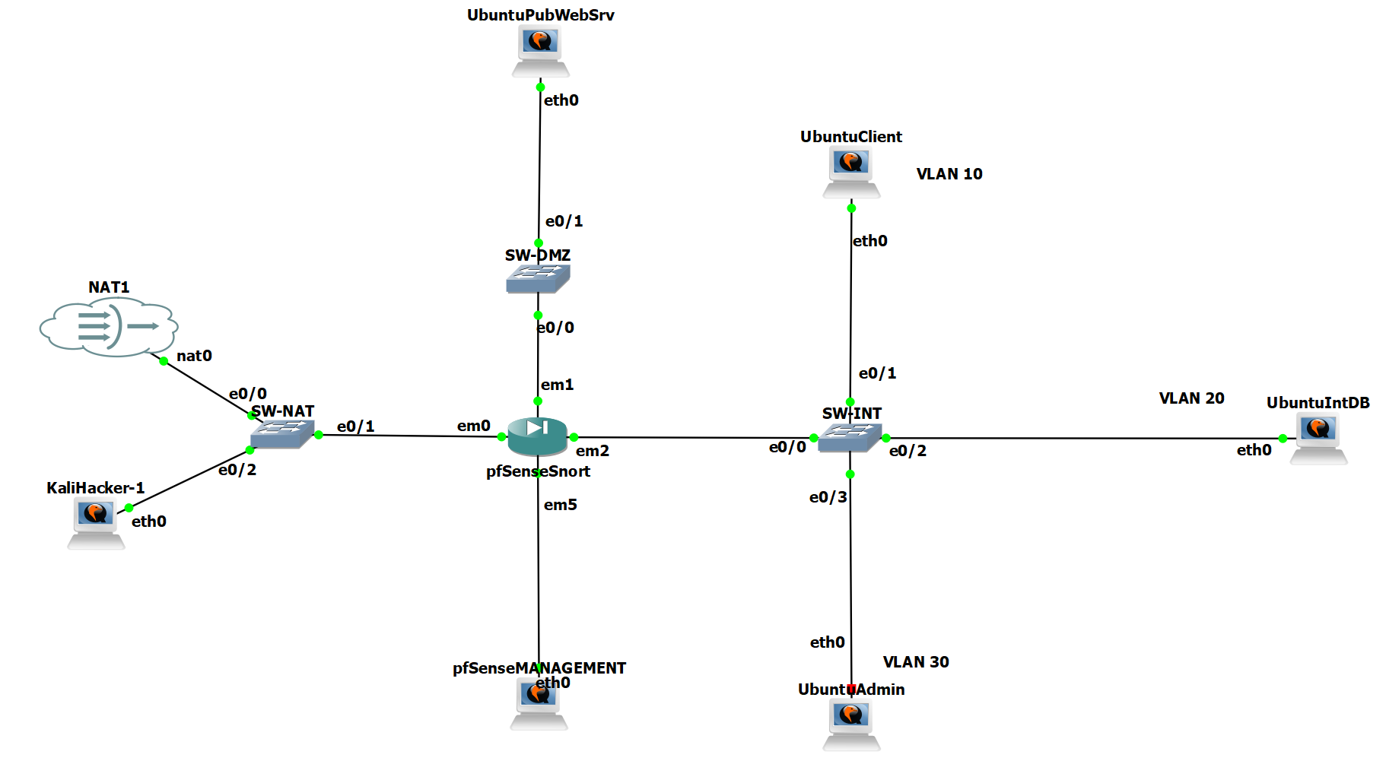

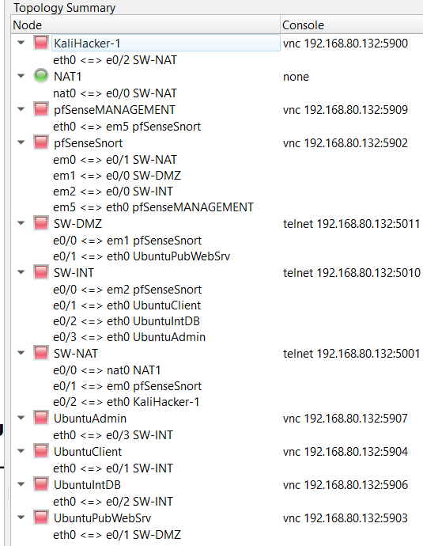

B. Network Segmentation and Firewall

Segmentation was further reinforced through a virtual firewall, in this case, pfSense, which was deployed as a VM with interfaces mapped to WAN, LAN, and DMZ networks and VLANS with parent LAN interface em2. Firewall rules were crafted to implement access-control lists (ACLs) that regulated traffic between segments. [Fig. 2] Only essential flows—such as HTTP/HTTPS from the DMZ to the internet or specific inter-department traffic—were permitted, while unnecessary or potentially malicious traffic was blocked. Logging had been enabled on all rules, allowing administrators to track violations and suspicious activities. After configuration, connectivity tests confirmed that the firewall behaved as intended. Nmap scans validated that exposed ports were limited to those explicitly allowed, ensuring that critical services were reachable while the attack surface remained minimal. This diligent rule-creation and validation process significantly reduced the risk of unauthorized access.

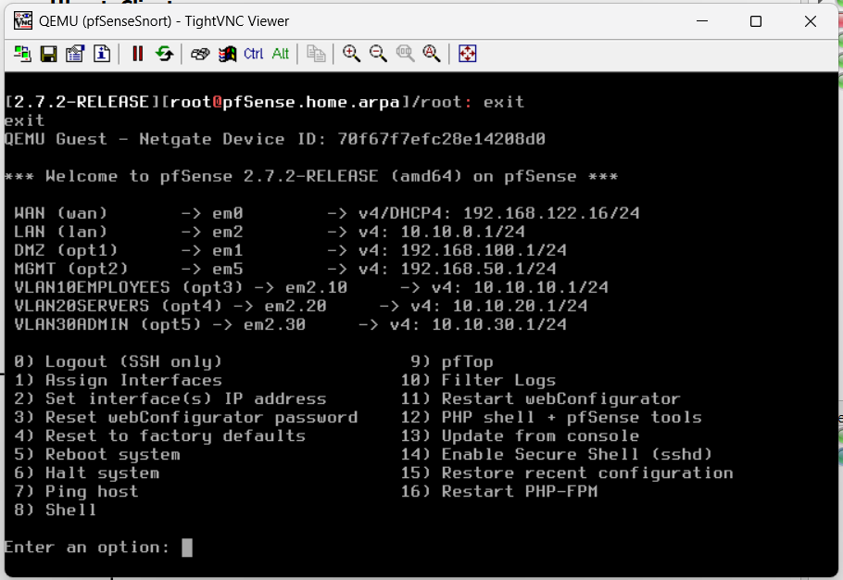
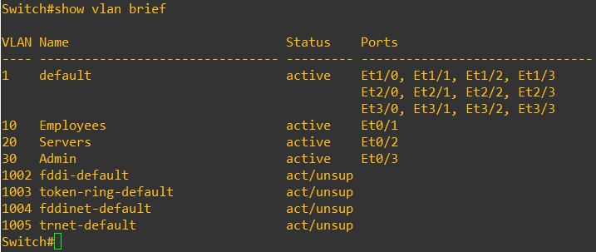
Figure 2

C. IDS/IPS Configuration

An IDS/IPS—Snort in this setup—had been installed on a dedicated VM and integrated with a TAP or span port to monitor traffic across network boundaries. Predefined rule sets were enabled to detect threats such as DDoS attempts, SQL injections, and port scans, while custom signatures addressed lab-specific concerns like unauthorized SSH attempts. Alerts were then tuned to minimize false positives and prioritize actionable events. Our team simulated attacks with Metasploit and custom scripts; Snort successfully detected and logged these activities. Subsequent fine-tuning improved detection accuracy and ensured critical alerts were escalated promptly. This continuous calibration process kept the IDS/IPS responsive to evolving threats while avoiding alert fatigue.

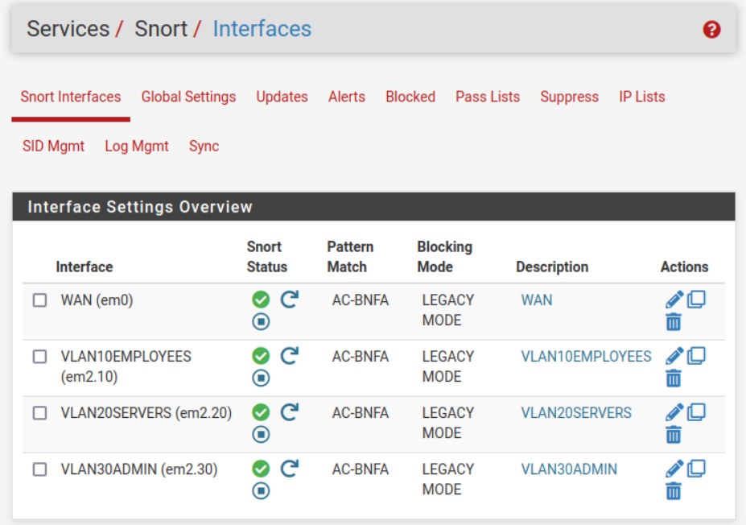

D. Testing and Security Assessment

Comprehensive penetration tests were conducted with tools like Nmap and Metasploit to enumerate open ports, identify vulnerable services, and validate segmentation controls. Cross-segment attack paths and external threat scenarios were explored, revealing any latent weaknesses in the design. Security validation verified that the firewall blocked unauthorized traffic and that VPN tunnels safeguarded data in transit, as confirmed via Wireshark packet captures. IDS/IPS logs were reviewed to ensure that malicious activity had been captured accurately. Finally, a risk assessment documented residual vulnerabilities and recommended mitigation strategies—patching outdated services, tightening ACLs, and enhancing monitoring—to further fortify the network’s security posture.

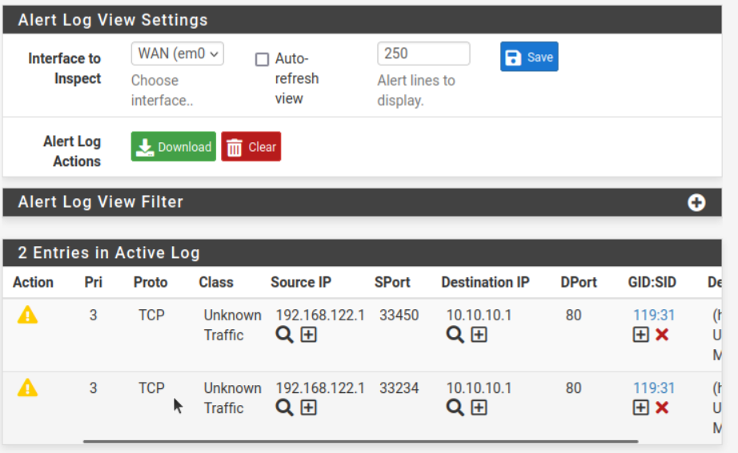

IV. FINDINGS

During our experiment, several key findings emerged regarding the setup and operation of a ZTNs. One significant limitation identified was the inability to implement identity-based rules with pfSense. In scenarios requiring user-specific access control—such as allowing traffic to the DMZ only if it originated from a specified user, such as Bob, for example—this limitation posed a challenge. As a result, our ZTN model lacked a layer of user authentication protection typically expected in a comprehensive zero trust architecture. Moreover, implementing zero trust principles necessitated the creation of explicit firewall rules for each network segment, including the DMZ, WAN, LAN, and INT-SW/internal network and VLAN segments. This setup required careful and detailed configuration, as rules had to be explicitly defined, such as blocking traffic from the DMZ to other interfaces or allowing traffic from the WAN solely to the DMZ based upon traffic. The complexity of managing these rule sets introduced potential risks. Specifically, the omission of even a single rule could create vulnerabilities by inadvertently providing entry points for attackers. This highlighted the critical need for meticulous planning and validation in firewall configuration to ensure all access controls were accurately enforced and monitored. Overall, our findings emphasized the importance of user identity integration in zero trust frameworks and the challenges associated with managing intricate rule sets in network security.

VI. DEPLOYMENT CONSIDERATIONS

Deploying a Zero Trust Network requires careful planning and adherence to best practices to effectively minimize security risks and enhance protection. Below are some key best practices for implementing a Zero Trust Architecture:

Identity and Access Management (IAM): Implementing a robust identity verification and access management controls.

Multi-factor authentication (MFA): Assure that only authorized users gain access to resources. Regularly review and adjust access permissions based on the principle of least privilege, ensuring users have only the necessary access for their role.

Micro-Segmentation: Divide the network into smaller, isolated segments to limit the lateral movement of potential threats. Each segment should have its own security controls and policies in order to reduce the overall attack surface and controlling access within the network.

Continuous Monitoring: Deploy continuous monitoring systems to detect and respond to anomalies and threats in real-time. Use tools like intrusion detection and prevention systems (IDS/IPS) and Security Information and Event Management (SIEM) solutions to gain visibility into network traffic and user behavior.

Explicit Security Policies: Establish clear and explicit security policies for all network traffic. Ensure that all network segments have defined firewall rules that are regularly reviewed and updated. Implement strict access control rules for sensitive zones, such as the DMZ, to prevent unauthorized access.

Data Encryption: Encrypt data both in transit and at rest. Employ strong encryption protocols to protect sensitive information, ensuring that even if data is intercepted, it remains secure and unreadable without the proper decryption keys.

Zero Trust Mindset: Adopt a zero-trust mindset throughout the organization. Educate employees about the importance of security and the role they play in maintaining a zero-trust environment. Encourage a culture of vigilance and continuous improvement in security practices.

CONCLUSION
Zero Trust Architecture (ZTA) is an essential innovation in the field of cybersecurity that replaces the old model that relied on perimeter-based protection with ongoing verification, minimal granting access, and strict separation. The present paper considered the fundamentals of Zero Trust, the issues organizations may encounter during its implementation, and the outcome of deploying a simulated Zero Trust Network with the help of some virtualized tools pfSense, VLAN segmentation, OpenVPN, and Snort IDS / IPS.

The environment showed the advantages and challenges of the Zero Trust implementation. Although micro-segmentation, controlled access, and constant monitoring enhanced the security significantly, the configuration also caused complexities, especially controlling detailed firewall rules and compatibility with legacy systems that do not have identity-sensitive features. Nevertheless, penetration testing helped understand that the Zero Trust policies could limit lateral movement and offered solid defense against typical attacks.

Generally, the paper has shown that the zero trust is an effective and required model to protect contemporary networks. Organizations, with appropriate planning, proper configuration and constant monitoring, can significantly improve their security posture and minimize their exposure to the changing cyber threats.

Reference
Chuan, T., Lv, Y., Qi, Z., Xie, L., & Guo, W. (2020). An Implementation Method of Zero-trust Architecture. Journal of Physics: Conference Series, 1651(10.1088/1742-6596/1651/1/012010), 012010. https://doi.org/10.1088/1742-6596/1651/1/012010
Lund, B. D., Lee, T.-H., Wang, Z., Wang, T., & Mannuru, N. R. (2024). Zero Trust Cybersecurity: Procedures and Considerations in Context. Encyclopedia, 4(4), 1520–1533. https://doi.org/10.3390/encyclopedia4040099
Mushtaq, S., Mohsin, M., & Mushtaq, M. M. (2025). A Systematic Literature Review on the Implementation and Challenges of Zero Trust Architecture Across Domains. Sensors, 25(19), 6118. https://doi.org/10.3390/s25196118
Reddy, R. P. (2025). Zero Trust Architectures in Modern Enterprises: Principles, Implementation Challenges, and Best Practices. International Journal of Computer Trends and Technology, 73(6), 48–57. https://doi.org/10.14445/22312803/ijctt-v73i6p107
Rose, S., Borchert, O., Mitchell, S., & Connelly, S. (2020). Zero trust architecture. NIST Special Publication 800-207, 1(800-207). https://doi.org/10.6028/nist.sp.800-207
Shaikh, al. (2024). Zero Trust Security Paradigm: A Comprehensive Survey and Research Analysis. Deleted Journal, 19(2), 28–37. https://doi.org/10.52783/jes.688
Yeoh, W., Liu, M., Shore, M., & Jiang, F. (2023). Zero trust cybersecurity: Critical success factors and A maturity assessment framework. Computers & Security, 133(1), 103412. https://doi.org/10.1016/j.cose.2023.103412

